# EXPERIMENT – 7

## Aim:

To display a histogram of an image and to perform histogram equalization on an image. Software used

## Software used:

MATLAB

## Theory:

A histogram is a display of statistical information that uses rectangles to show the frequency of data items in successive numerical intervals of equal size. In the most common form of histogram, the independent variable is plotted along the horizontal axis and the dependent variable is plotted along the vertical axis. The histogram is a popular graphing tool. It is used to summarize discrete or continuous data that are measured on an interval scale. It is often used to illustrate the major features of the distribution of the data in a convenient form.

Histogram of An Image: -

The graphical representation of an image's pixel intensity values is called a histogram. It can be understood as the data structure that keeps track of all the frequencies of the image's pixel intensity levels.

Image 1: [Histogram of an Image](http://www.doc.gold.ac.uk/~mas02fl/MSC101/ImageProcess/HIPR/histgram.htm)

The pixel intensity levels of the image are shown on the X-axis in the figure above. Typically, the intensity level runs from 0 to 255. There is just one histogram for a grayscale image, whereas there are three 2-D histograms—one for each colour—for an RGB coloured image. The histogram's Y-axis displays the frequency or quantity of pixels with a certain intensity value.

Code: -

clc;

I = imread("test.png");

figure

subplot(1,2,1)

imshow(I)

title('original image')

subplot(1,2,2)

imhist(I, 64)

title('before hist eq')

J = histeq(I);

figure

subplot(1,2,1)

imshow(J)

title('histogram eq')

subplot(1,2,2)

imhist(J,64)

title('after hist eq')

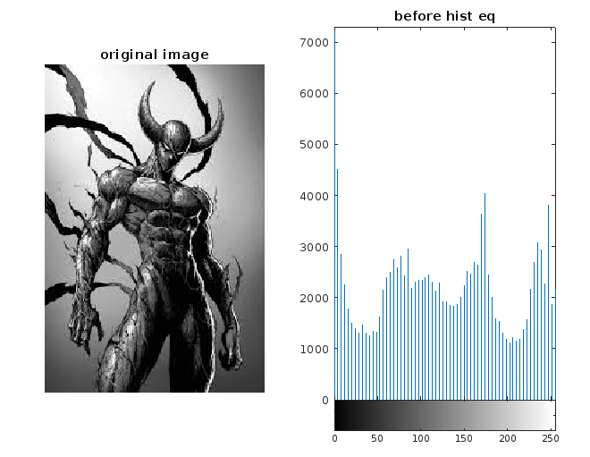

Image 2: before histogram equalization.

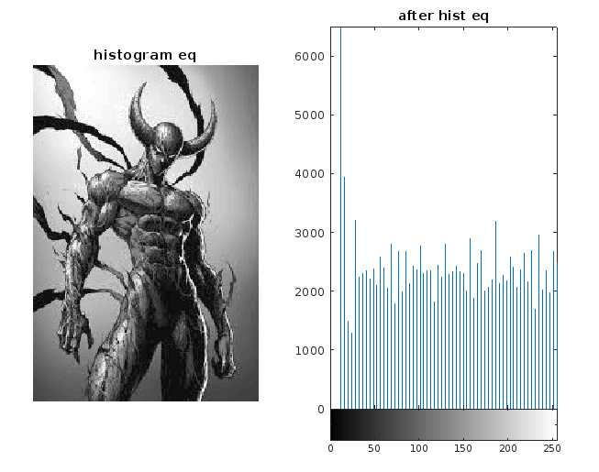

Image 3: after histogram equalization